Terraform Task

**Name:Shaik Khaja Basha**

**Batch : Batch 11**

**Date : 18.07.2025**

**Task : File creations in .tf & make corrections**

1. **make a mistake in configuration->run validate->correct and execute for that i had like abc.txt file in terraform**

**Ans: Open your terminal and run:**

mkdir tf_folder # Main folder for Terraform work

cd tf_folder # Move into that folder

mkdir 1807 # Create a sub-folder for today's date or task

cd 1807 # Move into that sub-folder

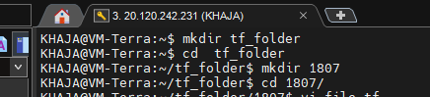

* Create Terraform configuration file
* vi file.tf
* In vi, press i to enter **insert mode**, then **paste this content**:

**Syntax** : resource "local_file" "filecreation" {

filename = "abc.txt"

content = "this is my first resource"

}

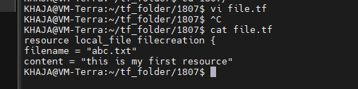

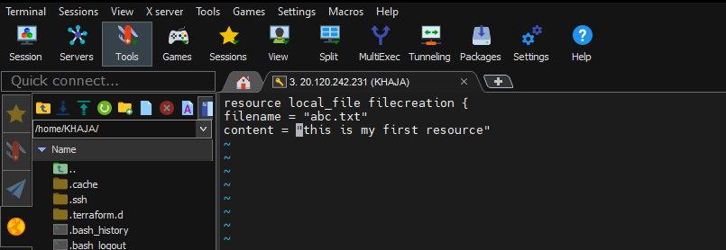

* Press Esc
* Type :wq and hit **Enter** to save and exit
* **Initialize Terraform**
* terraform init

This will download the required local provider plugin and set up .terraform directory.

**Output will look like:**

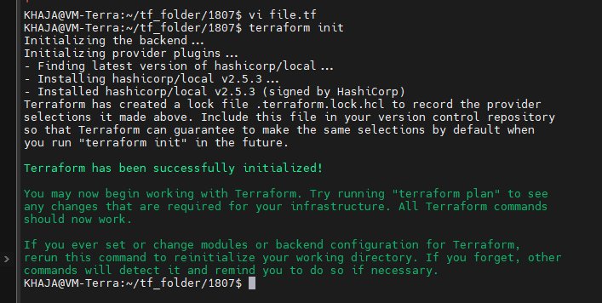

* **Validate the configuration:**

Check if your configuration is correct:

* terraform validate

output:

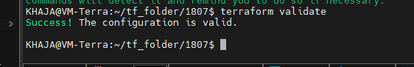

Its show me as validate “Success”

* **Plan the Infrastructure**
* terraform plan

This step shows what Terraform **will do** without actually doing it.

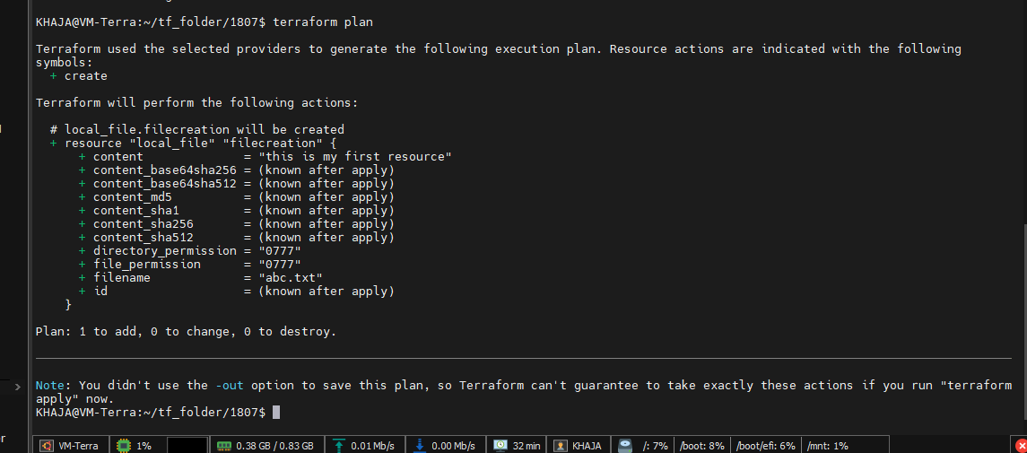

* **Apply the Configuration**
* terraform apply

This step actually **creates the file**.

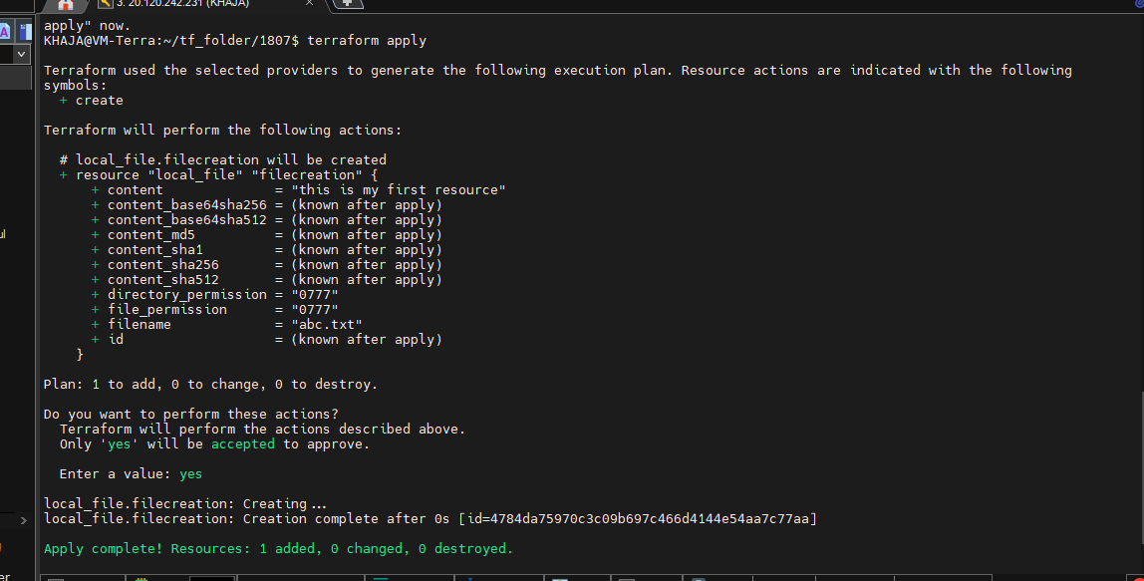

Verify Output

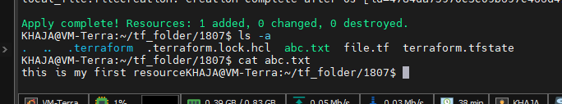

Add Terraform code with a mistake (Missing closing brace)

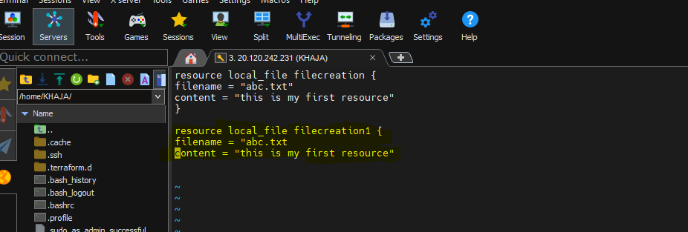

When I create a another resource within the same file but it show the error

* Terraform validate

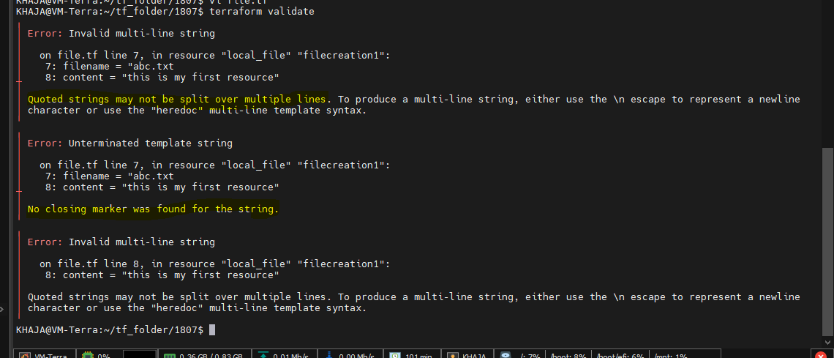

Lets correct the configuration and make execute

* Terraform apply

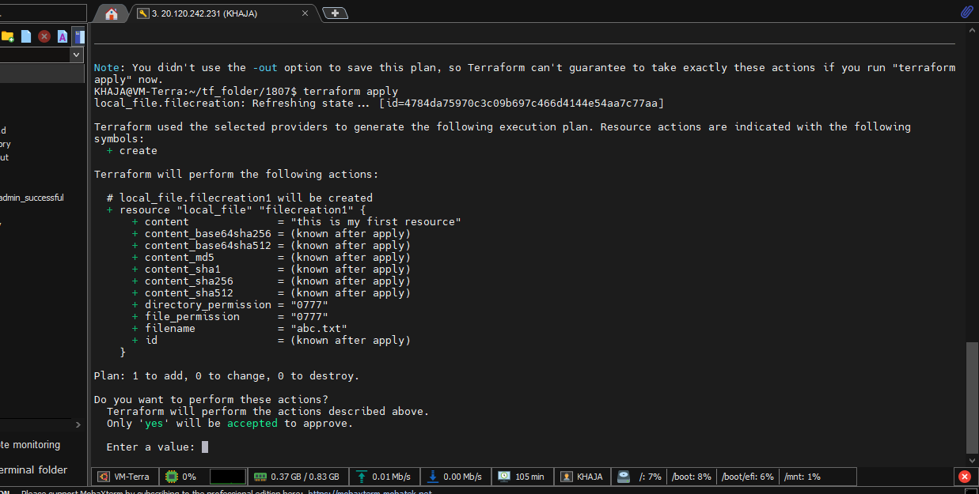

Know it will create a file with no error

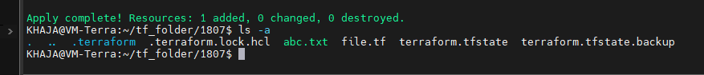

When we check the state file it will show the previous execution

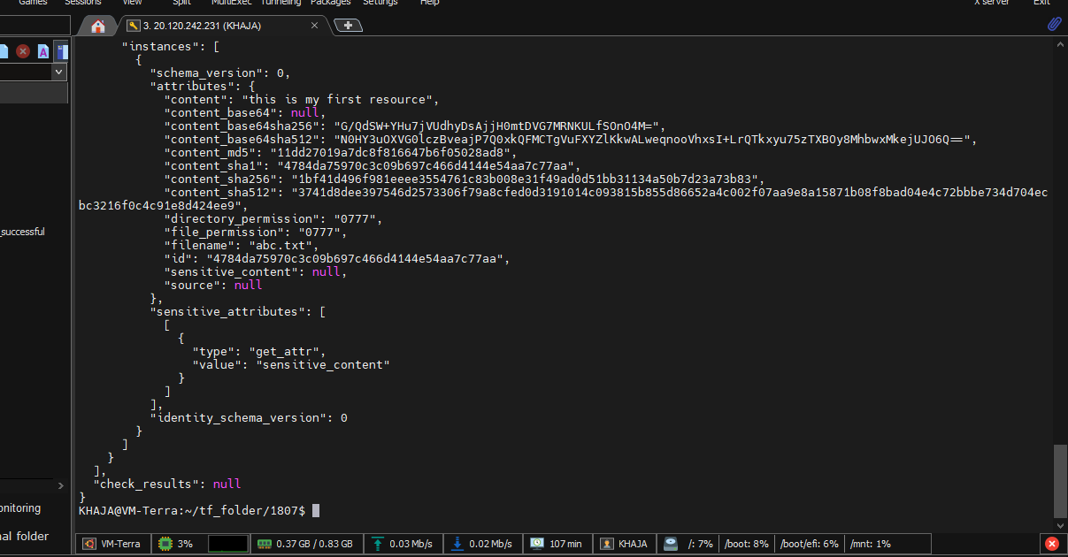

For the backup file it contain the previous execution

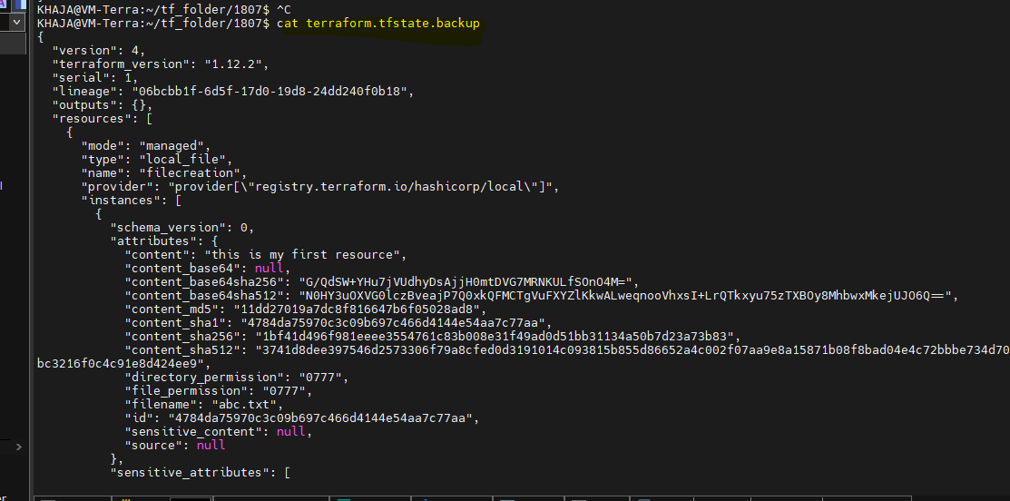

1. **create 3 .tf file with single resources inside**

Ans: three Terraform (.tf) files, each containing a single resource:

Creating files

Create a file name file1.tf using vi file1.tf

Enter the resource in file1.tf and save it esc:wq

resource "local_file" "filecreation1" {

filename = "abc1.txt"

content = "This is the content of file1 resource"

}

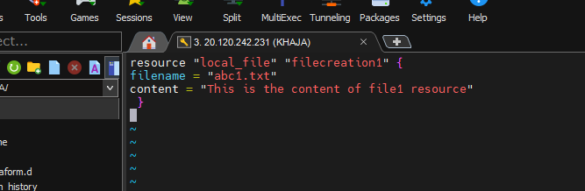

Know we have created file1.tf

Create the second file content file2.tf and save it esc:wq

resource "local_file" "filecreation2" {

filename = "abc2.txt"

content = "This is the content of file2 resource "

}

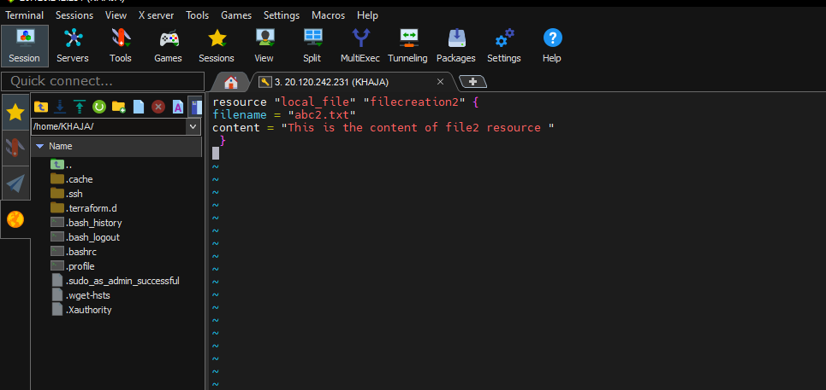

Create the third file content file3.tf and save it esc:wq

resource "local_file" "filecreation2" {

filename = "abc3.txt"

content = "This is the content of file3 resource "

}

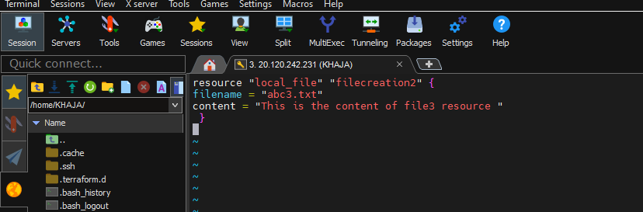

Run the command to Initialize Terraform

* terraform init

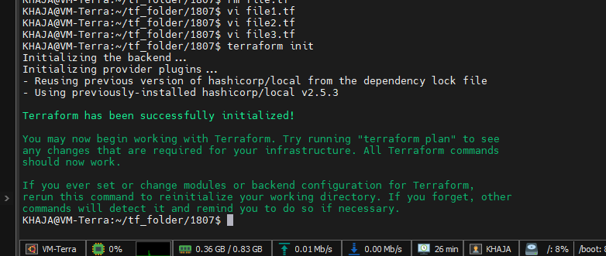

Will check for the validation

* terraform validate

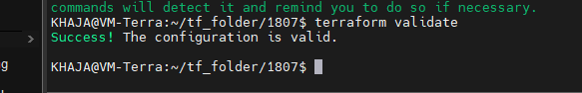

After that we need to run the following commands

terraform plan

* it will show a preview or dry run.
* It shows like What Terraform wants to create, change, or delete.
* No changes are made to our real environment when running plan.

terraform apply

* This is the action step.
* Terraform uses our .tf files to actually: to Create, modify, or delete real resources (VMs, networks, etc.).
* We will usually get a confirmation prompt before changes happen like for proceeding yes/No

Run the command terraform plan

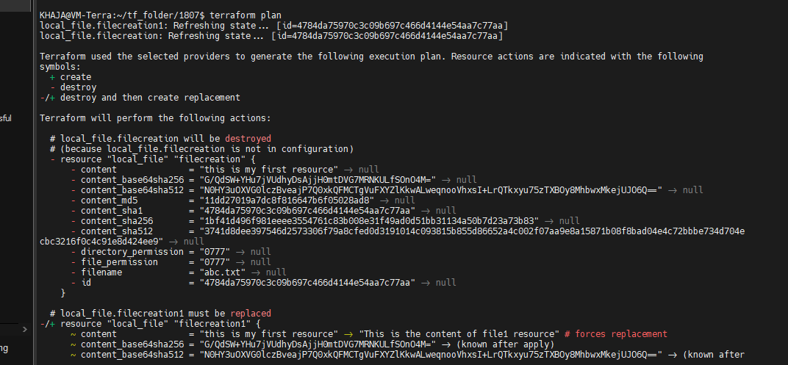

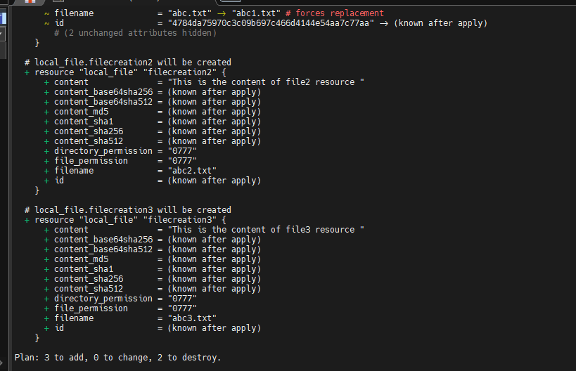

Run the command terraform apply

Terraform will show actions and prompt you for confirmation. Type yes when prompted.

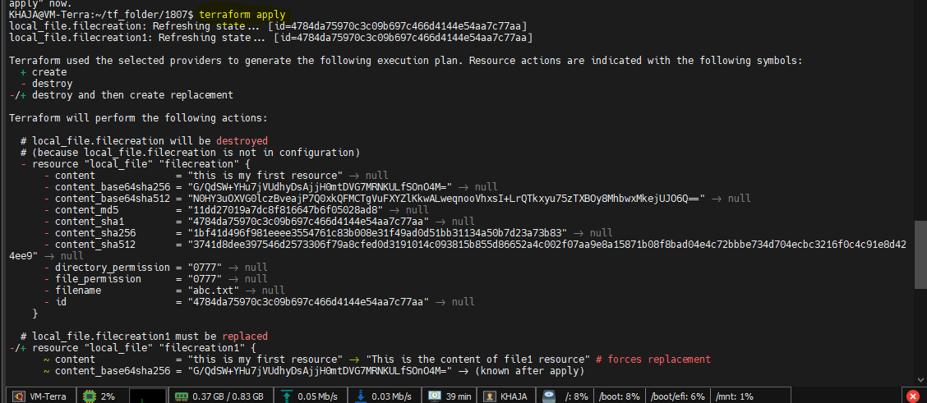

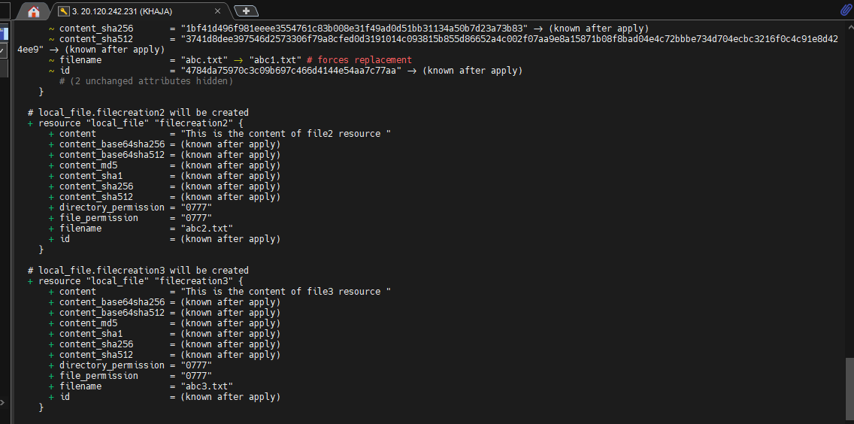

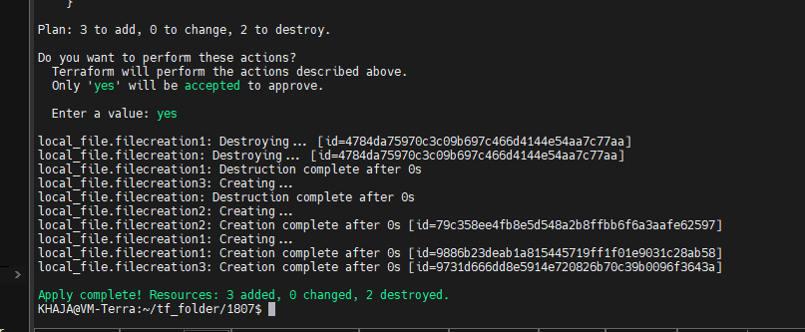

1. **Create single .tf file with three resources in it**

**Ans:** We need to create a .tf files, with a three resources in it, here is a clear structure and example content for each file, using the [local_file resource from the local provider]

**Create a single .tf file with:**

* **1 provider block**
* **3 resources:**
  + **abc1.txt**
  + **abc2.txt**
  + **abc3.txt**

**Creating file**

We create a file named main1.tf using vi file.tf

Enter the contents in file.tf as follows and save it using esc:wq

**resource "local_file" "filecreation1" {**

**filename = "file_1.txt"**

**content = "This is the content of file_1."**

**}**

**resource "local_file" "filecreation2" {**

**filename = "file_2.txt"**

**content = "This is the content of file 2."**

**}**

**resource "local_file" "filecreation3" {**

**filename = "file_3.txt"**

**content = "This is the content of file3."**

**}**

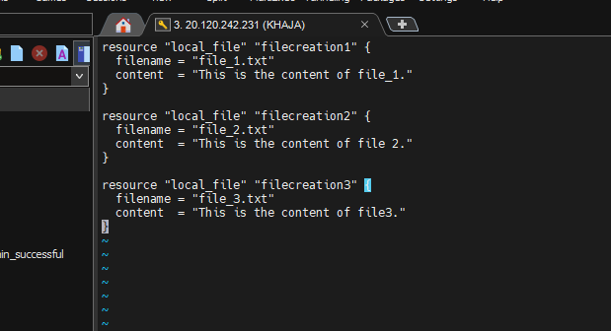

Initialize Terraform using command

* terraform init

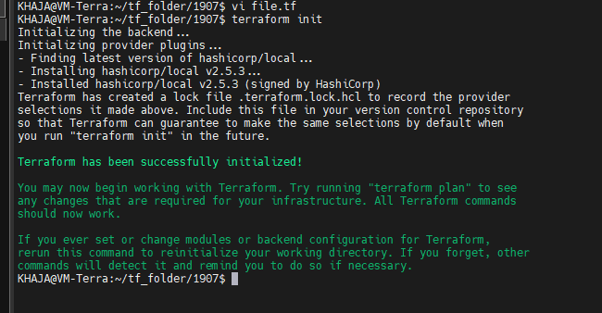

Check the contents using tree -a

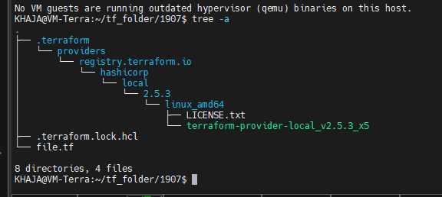

Run the command terraform validate

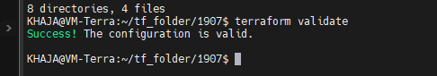

terraform plan

* it will show a preview or dry run.
* It shows like What Terraform wants to create, change, or delete.
* No changes are made to our real environment when running plan.

Run the command terraform plan

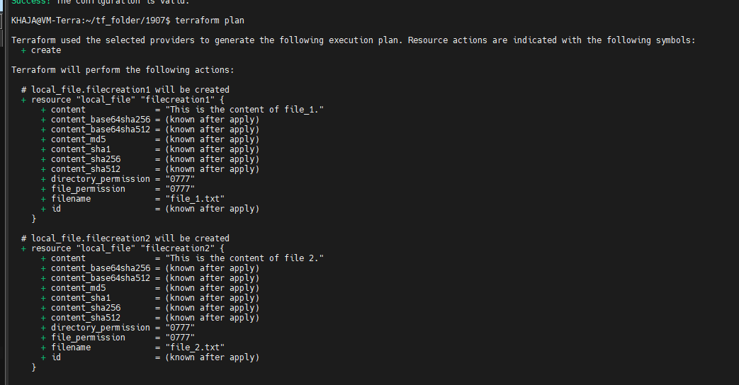

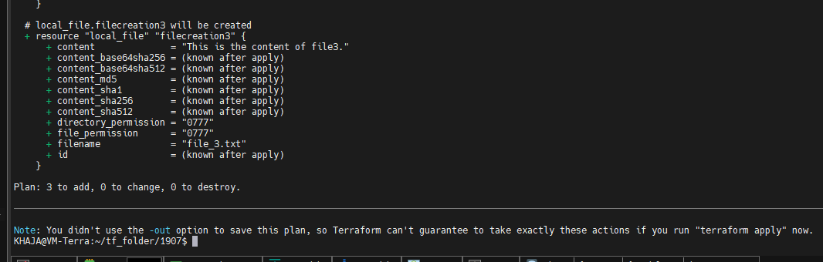

terraform apply

* This is the action step.
* Terraform uses our .tf files to actually: to Create, modify, or delete real resources (VMs, networks, etc.).
* We will usually get a confirmation prompt before changes happen like for proceeding yes/No

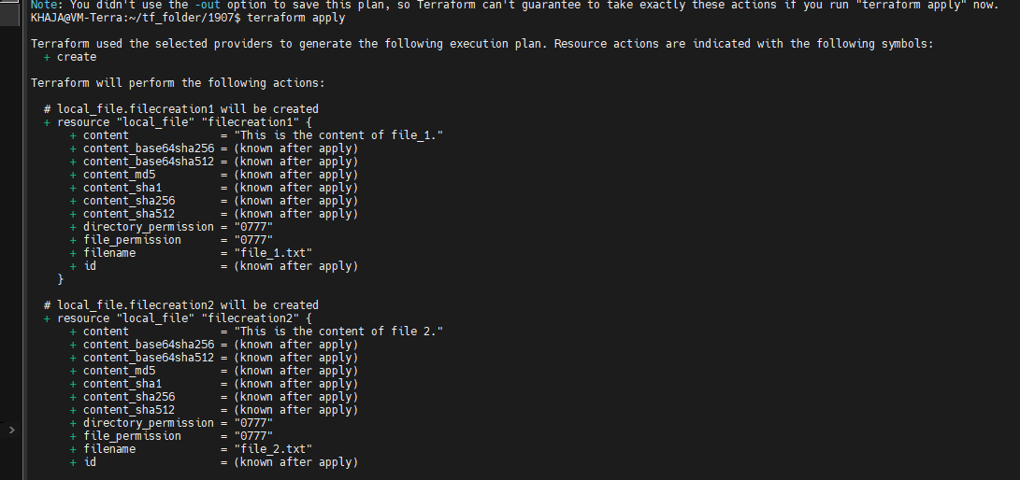

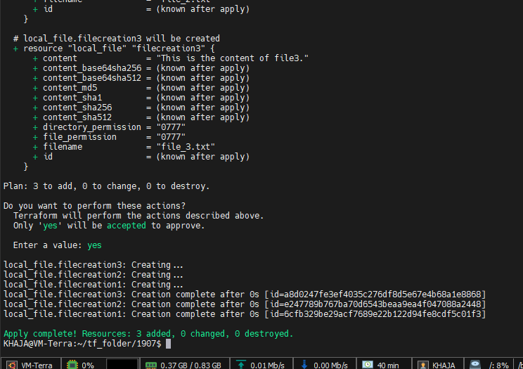

Check the contents of directory using tree -a

